Game design document

Di(e)ver

Caspar Bosch, Christian van der Helm, Kimberley van den Elzen.

Inhoudsopgave

* Meet the team
* Genre
* Motivation
* Mechanics
* The story
* Conclusions

Meet the team

In the beginning, there is the game designer.

The designer creates an experience.

The experience takes place in a venue.

The experience rises out of a game.

The game consists of elements.

The elements support a theme.

The game begins with an idea.

The game imroves through iteration

The game is made for a player

The experience is in the player’s mind

The player’s mind is driven by the player’s motivation.

Some elements are game mechanics.

Game mechanics must be in balance.

Game mechanics support puzzles.

Players play through an interface.

Experiences can be judged by their interest curves.

One kind of experience is a story.

Story and game structures can be artfully merged with indirect control.!!!!!!!!!!

Stories and games can take place in worlds.

Worlds contain characters.

Worllds contain spaces.

Some interfaces create a feeling of prescence.

The look and feel of a world is defined by it’s aesthetics.

Some games are played with other players.

Other players sometimes form communities.

The designer usually works with a team.

The team sometimes communicates through documents.

Good games are created through playtesting.

The team builds a game with technology.

Your game will probably have a client.

The designer gives the client a pitch.

The designer and client want the game to make a profit.

Game transforms their players.

Designers have certain responsibilities.

Each designer has a purpose.

Genre

Motivation

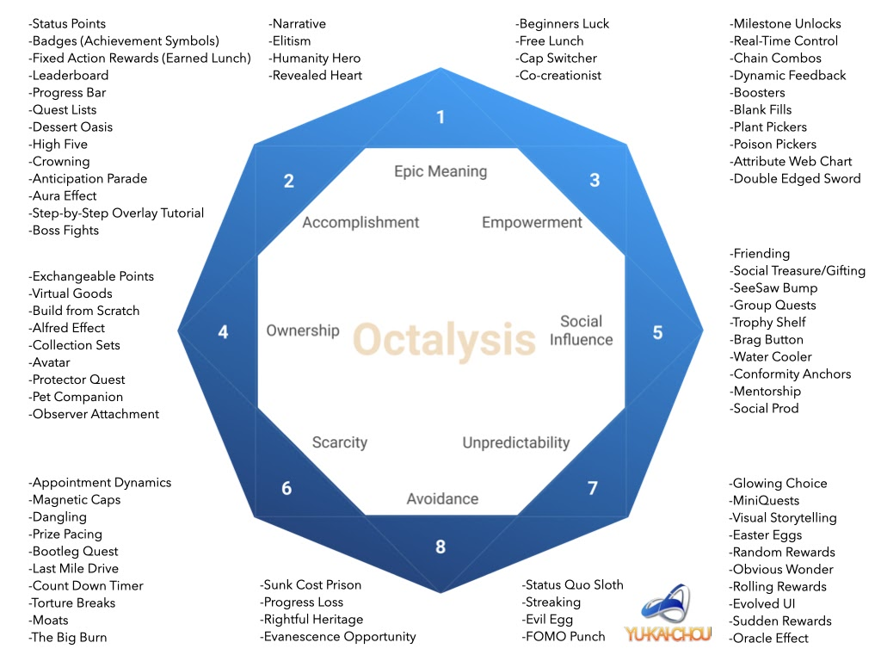

Mechanics

The story

Conclusions